Statistical Analysis of Online Retail Transactions

Lecturer: Taufique Ahmed
Due Date: 1/11/2026
Submission Date: 1/11/2026
Prepared by: Ei Khine Moe
Student Number: 2026845
Module Title: Statistical
Contents
AI Declaration using the AI Fluency Framework 16

Statistical Analysis of Online Retail Transactions
1. Introduction
The Online Retail dataset from the UCI Machine Learning Repository (Chen, 2015) was analyzed for this report. The Online Retail dataset contains 541,909 transactions of a UK-based online retailer from December 2010 to December 2011. There are many variables including quantity, unit price, date, and customer information. The report looks into the Online Retail dataset of a UK-based online retailer. There are 541909 records of online transactions of the retailer between December 2010 and December 2011. After removing records with zero or negative values for Quantity and UnitPrice, there are 530104 records left for the analysis.
First, a statistical analysis of the variables Quantity and UnitPrice is carried out by means of summary statistics and graphs. Subsequently, the binomial distribution is applied to bulk transactions, the Poisson distribution to the number of transactions per hour and the normal distribution of UnitPrice and sample. The suitability and limitations of the distributions of this dataset discussed as well.
2. Descriptive Statistics
After cleaning up the data, there are 530,104 lines of data for analysis. The average Quantity purchased is 10.54 with a median value of 3. The standard deviation is 155.52, showing a lot of variation in the number of products customers are purchasing. The average UnitPrice is 3.91 with a median value of 2.08. The standard deviation for the UnitPrice is 35.92. The histograms of the data showed that the majority of transactions were for low quantities and low prices. The histograms also showed that both the Quantity and the UnitPrice data were extremely right-skewed with a few very high data points. The box plots also highlighted the many possible outliers in the data. Of the Quantity values 56,363 (10.63%) were identified as outliers using the IQR method, while 37,999 (7.17%) of the UnitPrice values were identified as outliers. This does not necessarily mean that they need to be removed from the dataset, as some of these outliers could be very large orders of expensive products. The skewness for Quantity was 471.73 and for UnitPrice was 206.09. These two distributions are extremely right-skewed. The Pearson correlation coefficient between Quantity and UnitPrice is approximately -0.0038 which indicates there is almost no linear relationship between these two variables. The difference between the mean and the median of both the Quantity and the UnitPrice data is also an important characteristic to note. There are many transaction lines with very small quantities and very low unit prices, but there are also a few transaction lines with very large quantities and very high unit prices. These large values show that the mean is not as representative of the transaction lines in the data set as the median. The histograms and boxplots above as well as the summary statistics above help to make sense of the data.

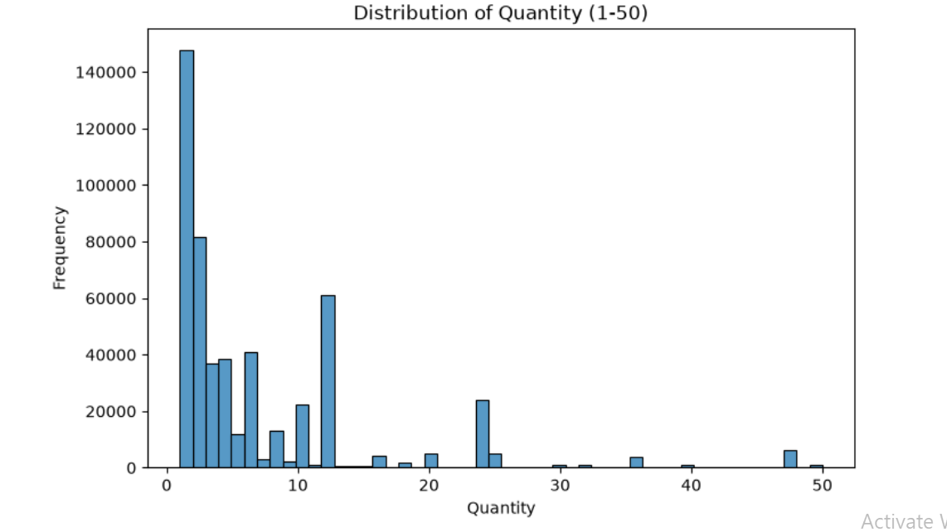
Figure 1: Distribution of Quantity (1–50)

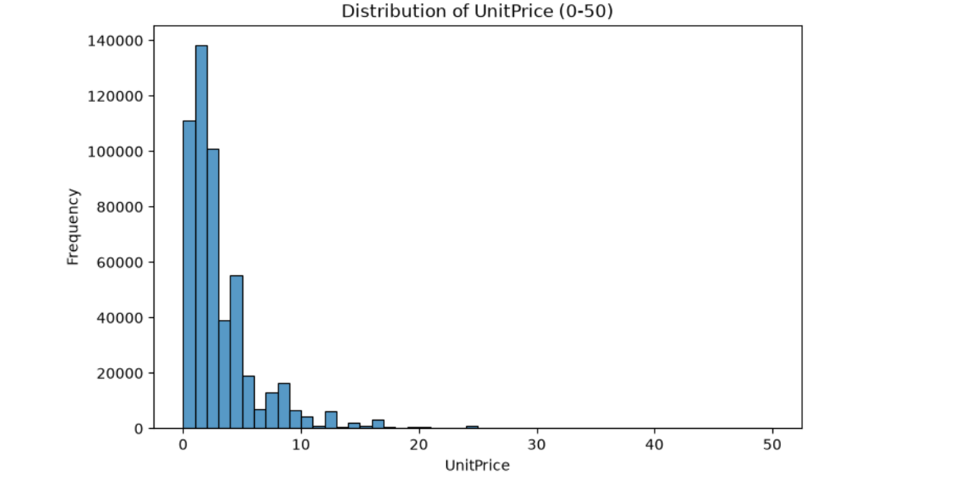

Figure 2: Distribution of UnitPrice (0–50)

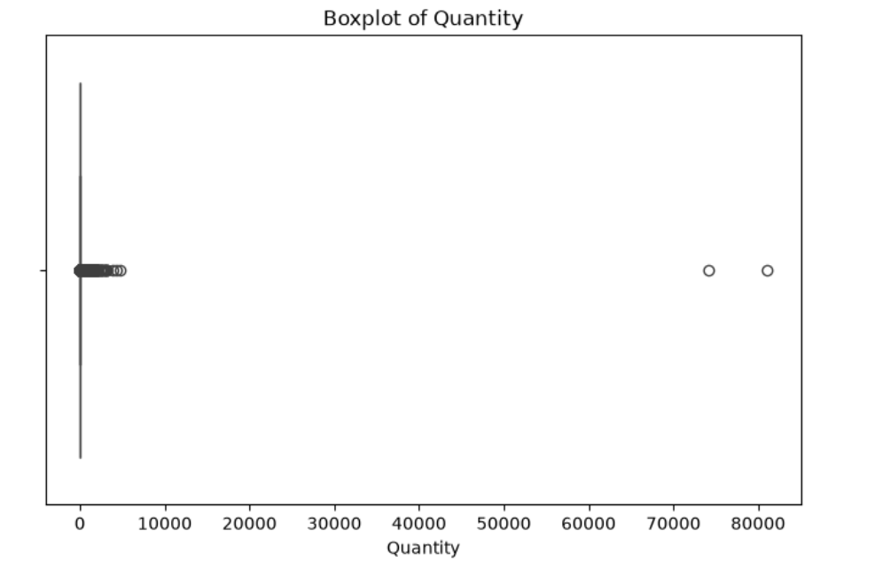Figure 3: Boxplot of Quantity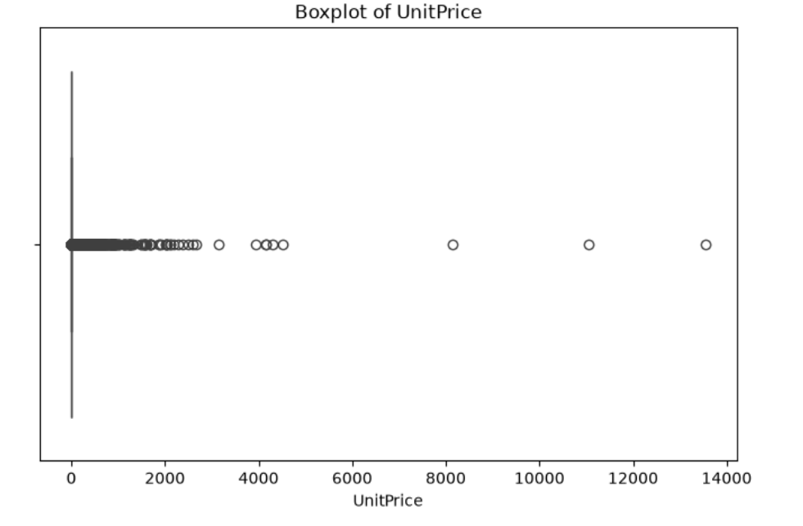
Figure 4: Boxplot of UnitPrice

3. Binomial Distribution
We can also apply the binomial distribution to the Online Retail dataset to find the probability of bulk transaction lines. For this analysis, the data was first cleaned to identify bulk transaction lines with a Quantity of 10 or more as well as standard transaction lines with a Quantity of less than 10. There are 154,513 bulk transaction lines out of 530,104 total transaction lines, or 29.15% (0.2915). We can model independent trials with fixed numbers of possible outcomes using the binomial distribution. Here each transaction line is assumed to be an independent trial with constant probability of being Bulk. We can use the formula to find the probability of exactly three Bulk lines in a sample of ten transaction lines.
Using the binomial distribution,the probability of geting exactly 3 Bulk lines for a sample of 10 transaction lines is binom.pmf(3, 10, p) where p = 0.2915. This is nearly 0.2664 or 26.64%.
These sample sizes of graphes (10, 30 and 100) as shown how the binomial distribution changes as the number of transactions increases. For larger sample sizes, the distribution became more symmetric and closer to a normal shape.
However, the independence assumption may not always hold because multiple transaction lines can belong to the same customer or invoice.

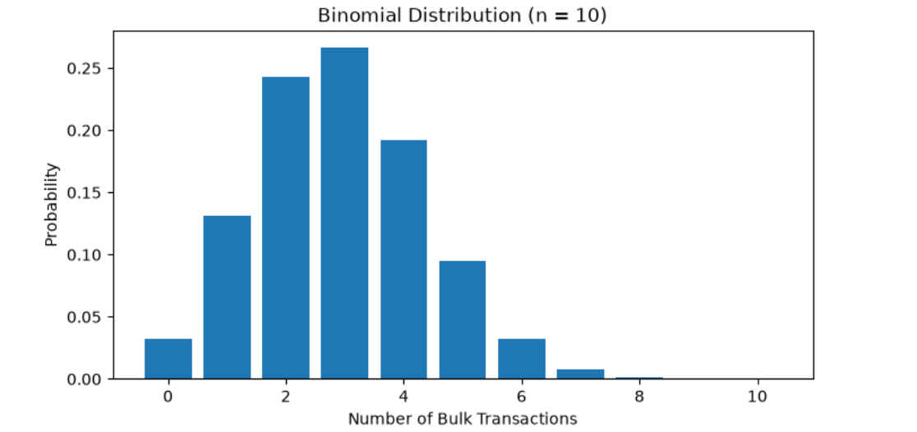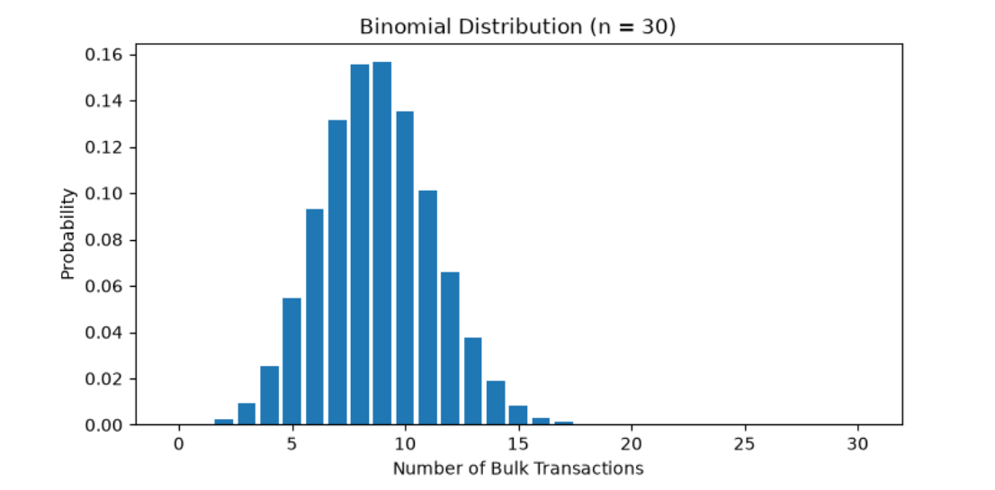

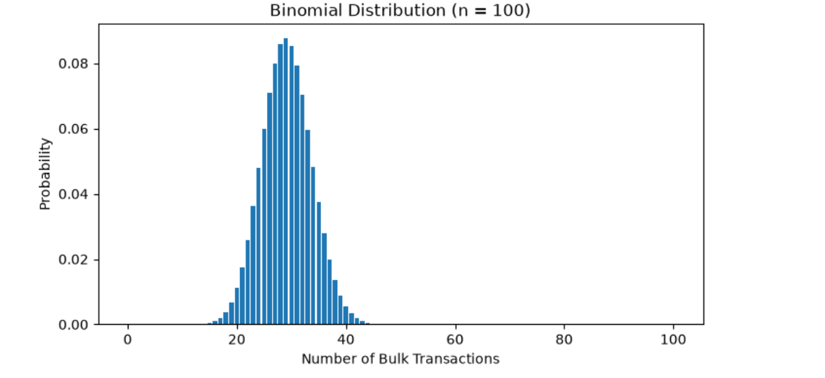
Figure 5: Binomial Distributions for Different Sample Sizes

4. Poisson Distribution
The Poisson distribution was chosen to model the hourly counts of transaction lines, as it is a common choice for count data of events occurring within a specified time frame at a constant average rate, independently of each other.
Mean number of lines of transactions per hour in active hours is 182.79, variance is 36,306.80. The ratio of variance to mean is 198.62. This ratio should equal to 1 for a Poisson distribution. Thus, the observe data do not follow a simple Poisson distribution. The comparison graph clearly shows that the hourly counts are more spread out than the Poisson model with the same mean. The graphs of the Poisson distribution with lambda = 2, 10, 30 and 100 also show how the distribution becomes more and more symmetric as lambda increases.
To explore the large-sample behavior, 500 sample means were generated for each of the three sample sizes (10, 30, and 100) using the hourly counts of the transactions. The sampling distributions became more concentrated and approximately symmetric as the sample size increased, thus showing the Central Limit Theorem.
However, the hourly counts do not follow a Poisson distribution. One limitation is that the analysis only included hours with recorded transactions. Transaction activity may also vary throughout the day, so a constant hourly rate may not be realistic.
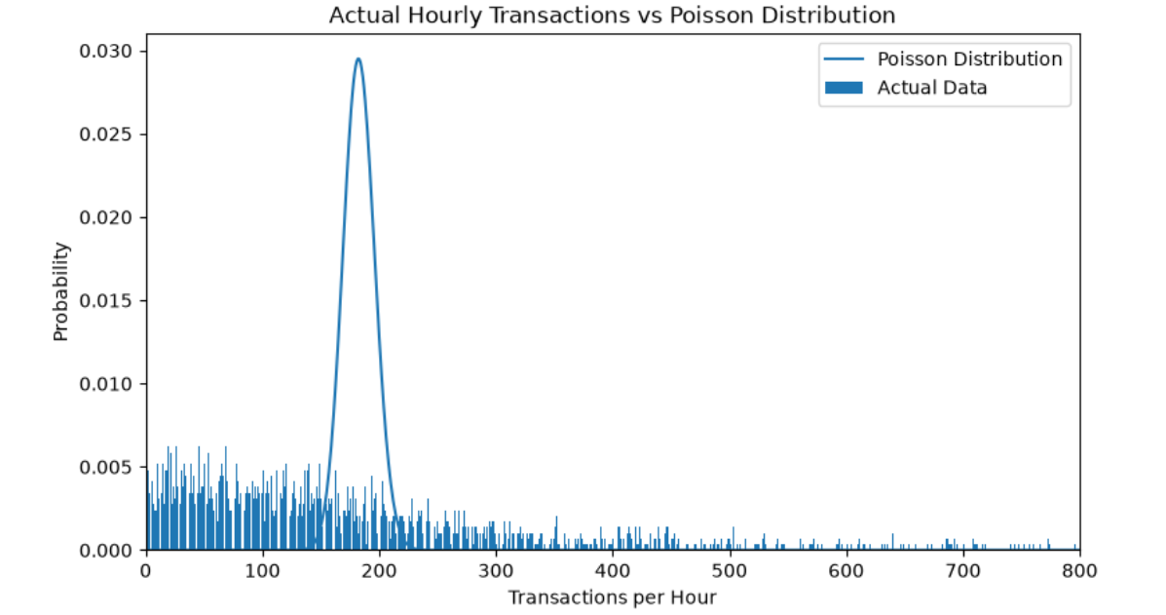

Figure 6: Actual Hourly Transactions Compared with the Poisson Model

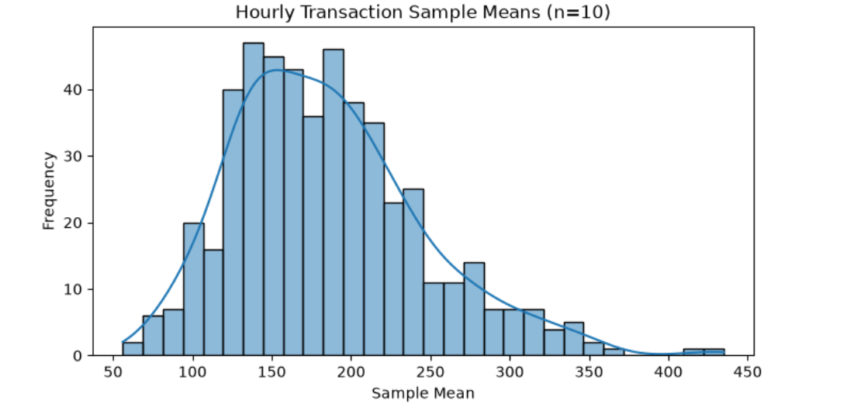

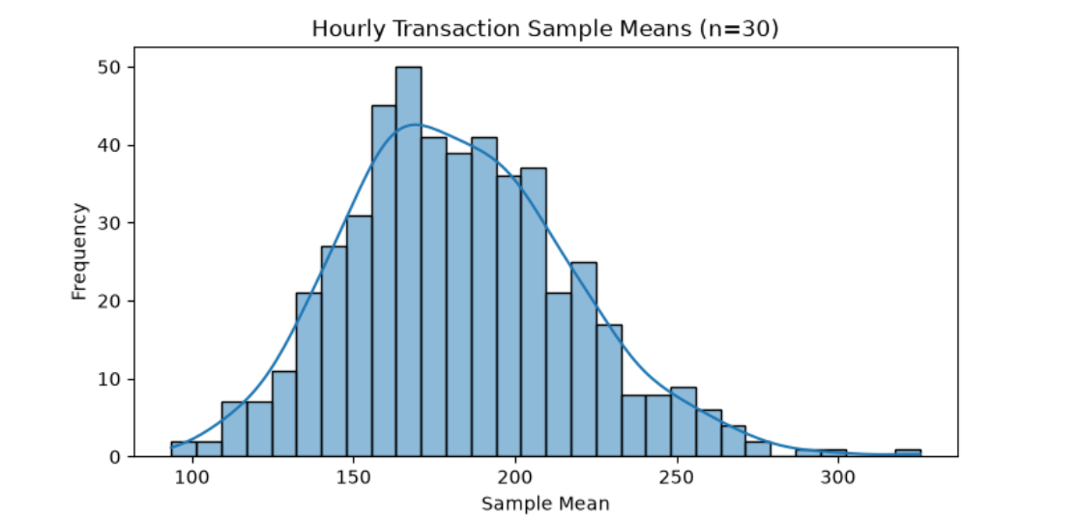

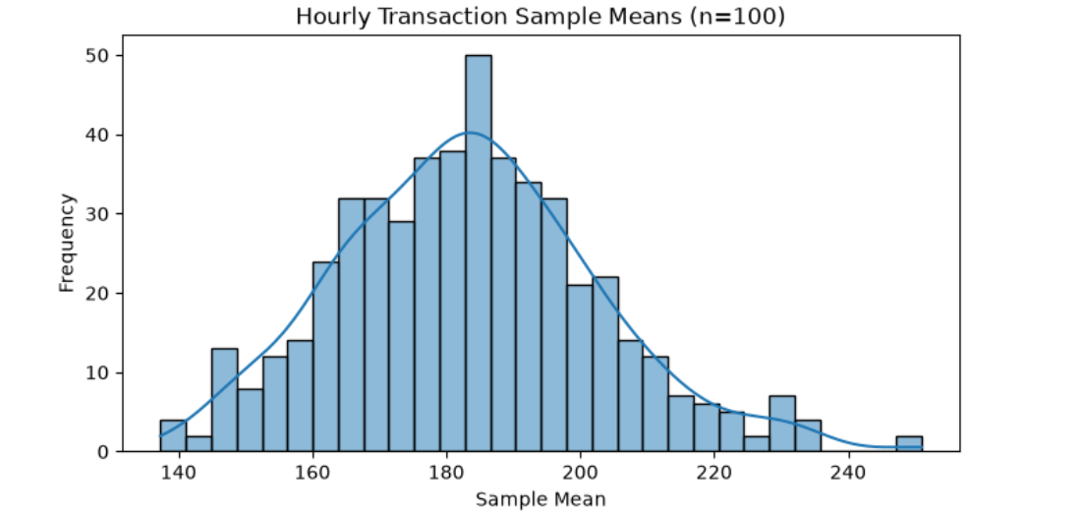

Figure 7: Sampling Distributions of Hourly Transaction Means

5. Normal Distribution
The normal distribution was analyzed for the variable UnitPrice and the sampling distribution of its mean value. The cleaned data for UnitPrice had a mean value of 3.91 and a standard deviation of 35.92. The distribution of the UnitPrice data was strongly right skewed and the Q-Q plot showed that the data did not follow a normal distribution. Most of the extreme values were on the high side.The sampling distribution of the mean was also looked at in terms of the Central Limit Theorem (CLT). 500 sample means were generated for different sample sizes (30, 100, 500, 1000) and the resulting sampling distributions plotted. As the sample size increased the sampling distributions became more concentrated but still displayed some right skewness due to the presence of some extreme values.
For a sample size of 1,000 the standard error is approximately 1.1358. The probability that the sample mean of UnitPrice is less than 5 using the normal approximation is 83.19%.However, the probability from the simulation of 500 samples of size 1,000 was 90.20%. This is a difference of 7.01%.The difference between the results obtained from normal approximation and those obtained from the simulation, therefore, highlights the need for careful application of the CLT when extreme outliers are present in the data.

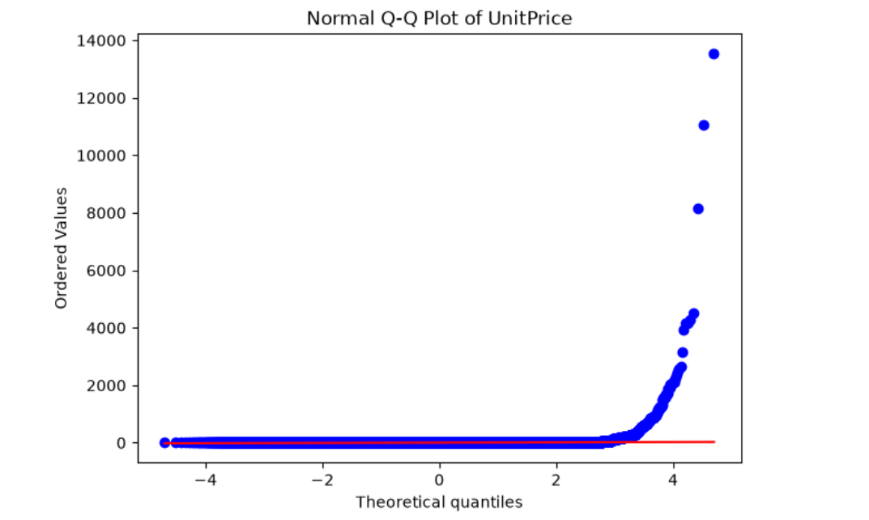

Figure 8: Normal Q-Q Plot of UnitPrice

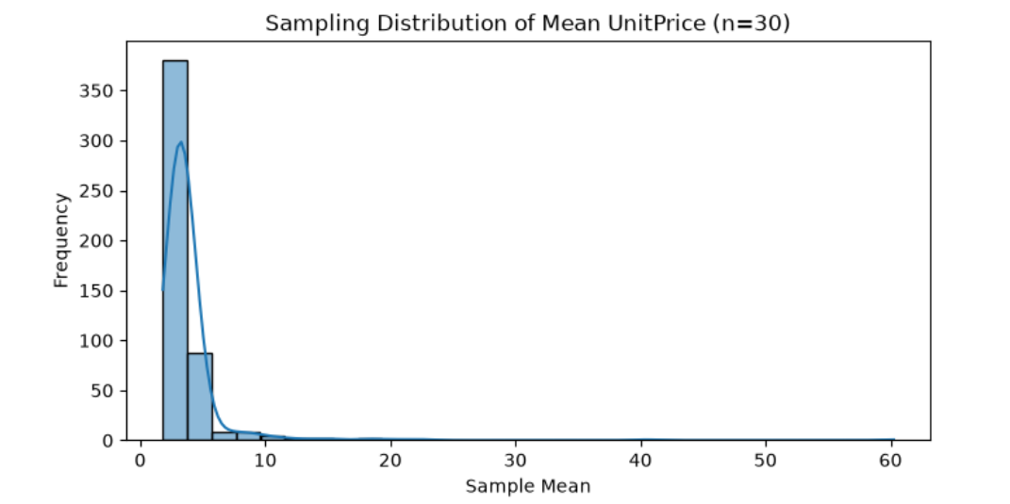

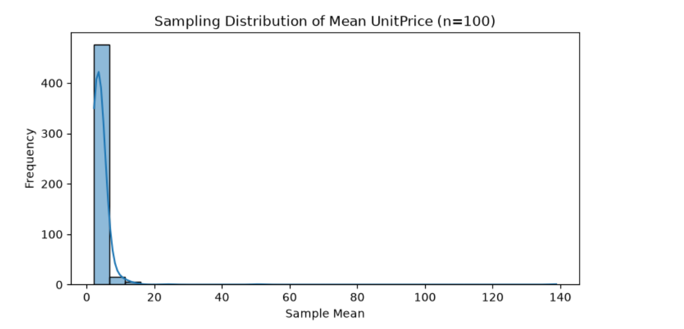

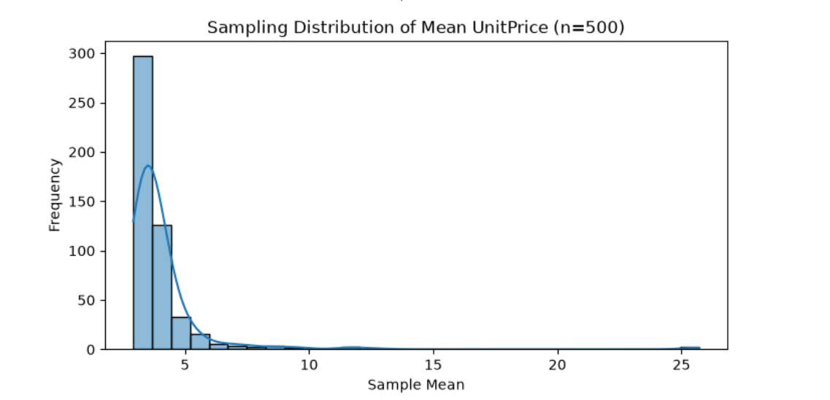

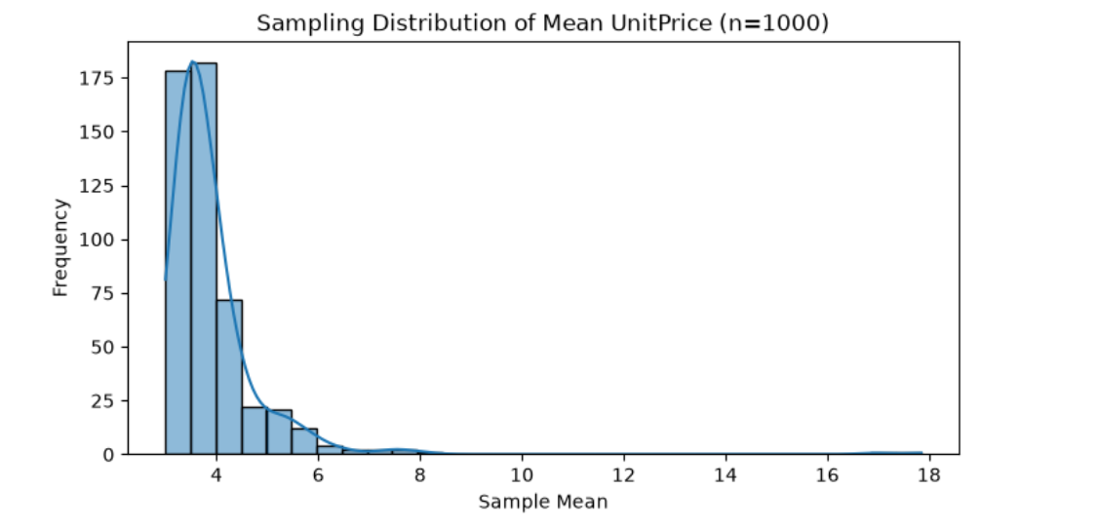

Figure 9: Sampling Distributions of UnitPrice Means Values for Different Sample Sizes (n = 30, 100, 500 and 1000)

6. Distribution Justification and Limitations
These distributions were chosen to match the different types of variables that we have in the dataset.
First, we use the binomial distribution for the classification of transaction lines into Bulk or Standard. Then we use the Poisson distribution for the number of transaction lines per hour.
Lastly, we investigate the normal distribution of the variable UnitPrice and its sample means.Both the binomial and the Poisson distribution are discrete. The normal distribution is continuous. For a binomial distribution, the normal distribution can be used as an approximation if the product of n and p as well as the product of n and 1-p is large enough. Here n=100 and p=0.2915, thus np=29.15 and n(1-p)=70.85.
So tat, the normal distribution can be used as an approximation if the assumptions of the binomial distribution are met.
The Poisson distribution turns into more balanced for lambda increases.
However, the hourly counts of transactions in this data set have a variance much larger than the mean.Thus, the Poisson distribution would not be a good model for these counts, and therefore, a normal approximation based on this Poisson distribution would also not be good for these counts.
Overall, selecting a probability distribution to use for data analysis depends on the type of data as well as the assumptions that are made for the distribution.
7. Conclusion
The study of online retail transactions was conducted by means of descriptive statistics and three probability distributions. Quantity and UnitPrice were found to be strongly right-skewed and therefore influenced by extreme values in their means and standard deviations.
The binomial distribution can used to estimate the probability of bulk transactions.
However, it must be noted that records are not necessarily independent. The Poisson distribution has also been investigated for hourly transaction counts.
However, the difference between the mean and the variance was too great to use the distribution on the actual data.
The Central Limit Theorem was also examined for the sample mean of UnitPrice. The sampling distribution for larger sample sizes got more concentrated but the extreme values for UnitPrice still affected the normal approximation.

In summary, statistical distributions can be used to describe the transactions of a retail store, but one must be aware of the assumptions made by each distribution and the limitations of each.

References
Chen, D. (2015) Online Retail [Dataset]. UCI Machine Learning Repository. Available at: https://doi.org/10.24432/C5BW33 (Accessed: 27 October 2026).

AI Declaration using the AI Fluency Framework
For use in assessment briefs and student submissions. Lecturers complete the Lecturer Expectations column per assessment; students complete the Student Response column.

AI competence | Reflective prompts (to students) | Lecturer expectations | Student response
Delegation  Deciding whether & when to use AI | Identify the specific tasks in this assessment where you chose to use AI, and explain your reasoning. Where did AI add value? Where did you decide not to use it, and why? | You may use AI to support your learning and development of the application. Clearly identify where you used AI and where you completed the work independently. | I used ChatGPT AI for more understanding of statistics.For eg, I asked ChatGPT to explain the binomial distribution, Poisson distribution and normal distribution in both the English and Myanmar languages. It used for many other things such as brainstorming, providing example codes,solving errors and helping to improve the explanations in my report.
Description  How you prompted the AI | Include the exact prompts you used in your appendix (recorded on the AI Tools declaration). Reflect on how you communicated your goals to the AI — did you need to iterate or refine your prompts to get useful output? | You must provide the exact prompts and relevant AI outputs used during the development of your application. | I asked ChatGPT some questions about statistics and Online Retail dataset. I also asked ChatGPT for some explanations in Myanmar language because it would help me understand better. I also asked for Python code examples, sample sentences for the report. If some of the explanations were too difficult to understand I asked further questions to get more clarification. The exact prompts and the corresponding AI outputs can be found in the appendix on AI-use.
Discernment  Evaluating what the AI produced | In your reflection, critically evaluate the AI output: what did you accept, modify, or reject — and why? Assess accuracy, relevance, and quality. You are responsible for verifying all AI-generated content before submitting. | You are responsible for checking, testing and understanding any AI-generated code or suggestions before using them in your work. | I have read through the AI suggestions for the code and tested it out in the Jupyter Notebook. The results and graphs matched up with the data I used in the report. I also checked the explanations given for the results and made some changes where I thought it was appropriate.
Diligence  Responsibility for your AI use | Declare all AI tools used and cite them here. Briefly outline how you considered data protection, copyright, and ethical responsibilities when choosing what to input into any AI system. Unauthorised use is subject to CCT disciplinary procedures. | Declare all AI tools used. Do not enter personal, confidential or sensitive information into AI tools. Any external sources used should be appropriately referenced. | ChatGPT has been used for learning and writing purposes. The suggested code and explanations have been checked before they were used in the assignment.  The data used for this report is the publicly available UCI Online Retail dataset, referenced in the report. I am responsible for the analysis and the final version of the report.

AI Prompts
Prompt 1: "Can you explain binomial, Poisson and normal distributions in simple English and Myanmar language?"
Binomial distribution is used for a fixed number of trials with two outcomes, using n and p to calculate probabilities. Poisson distribution models the number of events in a fixed time period using an average rate (λ). Normal distribution is a bell-shaped distribution using to study continuous values and sample means with examples codes and explanation.
Prompt 2: "How can I apply these three distributions to the UCI Online Retail dataset?"
Use Quantity to classify Bulk and Standard transaction lines for binomial analysis. Use InvoiceDate to calculate hourly transaction counts for Poisson analysis. Use UnitPrice to investigate normality and the Central Limit Theorem.
Prompt 3: "Can you explain how to calculate binomial probability using Python in Jupyter Notebook?"
Use binom.pmf(3, 10, p) where p = 0.2915. This is approximately equal to 0.2664 or 26.64% and represents the probability of exactly three Bulk lines in a sample of ten transaction lines with independent trials.
Prompt 4: "Can you help me understand and improve the statistical explanations in my CA1 report?"
Explain the purpose of the statistics used in the analysis and describe the results obtained and graph used in the report.
For example, the binomial results obtain a 26.64% probability of exactly three Bulk lines in a sample of ten lines. Also list any limitations, i.e. assumption of independent events and variation in hourly transaction counts.

